IMC Campaign Plan for Bionade
Name
Institution
Date

IMC Campaign Plan for Bionade
Target market
The target market for IMC campaigns will be strictly from Singapore city, and it will be concerned about middle and high-income earners aged between 14 and 65 years. Demographic marketing segmentation will be applied to identify the income levels of the target population(Akpoyomare, 2015). Among the most crucial reason for choosing this target market is because this category of persons may have an extra coin to purchase the beverage due to their moderate and high living standards(Vernuccio&Ceccotti, 2015). Besides, those living beyond the poverty line may not be able to buy, since they only concentrate on basic needs. Power Distance index score, as one of Hofstede's dimensions, is recorded at 74, meaning that the target population beliefs and expects power to be equally distributed(Vassileva, 2017). Income distribution for middle-income earners ranges between $9,023 and $9,293. Besides, that of high-income earners ranges between $10,400 and $15,000. IMC pricing will be based on the current market demands, prices of competitors, and the cost of manufacturing the product.
The positioning of the product
Positioning can be defined as the perspective of the target market towards a particular product concerning that of competitors. The positioning of Bioande will put more emphasis on the 4ps of the marketing mix; product, price, place, and promotion. Notably, the target market should have a clear view of the products in regards to its name, composition, and use (Akpoyomare, 2015). Again, the price of bioande should be in line with market demands and the costs of competitors. The advertisements should be launched within the busy street, places where one can find the target population. Akpoyomare (2015) suggested that the type of promotion on the product should be understandable and located at a strategic location to be viewed by a wide range of potential customers. The marketing of Bioande receives a challenge from rival products from other competitors, including Coca-Cola and Malaysia Dairy industries. Positioning bionade in the market will face competition since the Coca-Cola Company has a well-established market across all populations. As a result, the promotion will be tactically designed to show more advantages of buying bioande as compared to products from rival companies. The new image of Bionade will entail credible, attractive features to appeal to the target population.
Creative one-Billboard
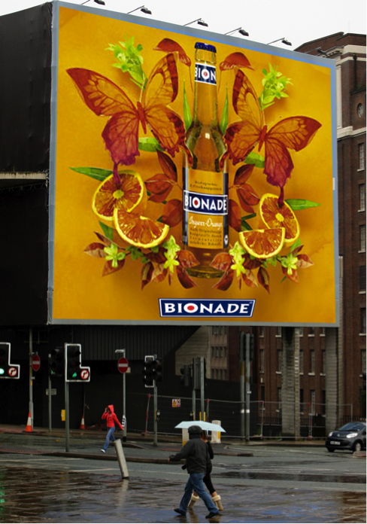
Context and justification
The first creative is an outdoor billboard with Boonade’s brand, which will be located in the busy street and roundabouts within Singapore city CBD (Vernuccio&Ceccotti, 2015). This type of advertising will contribute significantly to escalating sales of bionade since it has the potential of reaching middle and high-income earners aged between 14 and 56 years (Vernuccio&Ceccotti, 2015). Billboard will be an efficient method for marketing because it can be reached by the target market quickly due to its strategic positioning. The primary purpose of the billboard is to create awareness of the product to both existing and prospective customers. The entire advertisements will have the same design, and similar tag line “Ferment Your Thirst” will as well be featured in all the billboards.
Creative two- 3D picture
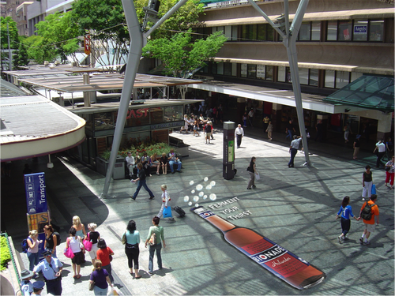
Context and justification
The above picture represents a 3D advertising of bionade drink. A 3D picture will be far much different from a billboard in the sense that it is normally drawn on the ground. It is among the attractive types of advertising, which are placed on the sidewalks where potential customers can stand to have a broad view.3D advertising will be positioned on busy streets, where middle and high-income earners aged between 14 and 56 years can see while shopping or accessing their jobs (Vassileva, 2017).As such, they will stand a higher chance of noticing the ad. The existing and interested customers will take a photo of the picture and post it on social media platforms, including Facebook and Twitter. As a result, it will be able to reach a considerable number of persons in Singapore (Akpoyomare. 2015). In addition to 3D pictures, bionade men will be distributed in the streets of Singapore, whereby they will do free artwork, graphics, and animations of the brand.

Creative three- Coater/table advertising
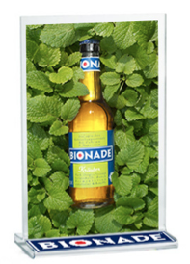
Context and justification
Table advertising is also an outdoor method for creating awareness of the product to potential customers. It entails designing table coaters for family-style based -restaurants located at busy streets, hotels, clubs, cars, and cafes. This approach will require the company to develop strands with a bionade brand that will stand firmly on the serving tables of the above-mentioned places (Akpoyomare, 2015).Coater advertising will easily accessible to middle and high-income earners aged between 14 and 56 years since a considerable number of them dine from family-style restaurants where the table adverts will be positioned. Again, this approach will instigate customers to buy due to its inclusion in the restaurant's menu (Vassileva, 2017). It may happen that some customer does not know of bionade existence. As such, they will have the opportunity to familiarize themselves with the drink as a result of advertisements displays.

Appropriateness and Cohesiveness of Campaign for Selected Target Market and Positioning
The selected campaign methods are effective yet cohesive as far as middle and high-income earners aged between 14 and 56 years, and positioning is concerned. The note attached to each creative “Ferment your thirst” ad will instigate the target population to buy Bionade drinks in an effort to quench their thirst. The first campaign method is billboards that will be strategically positioned at busy roundabouts of Singapore (Akpoyomare, 2015). This method will be cohesive and appropriate middle and high-income earners aged between 14 and 56 years since they occupy the largest population with better living standards, thereby standing a higher chance of making more purchases. On its part, 3D advertising pictures in Singapore city is also useful for the target population, because it is in busy streets where all these persons pass by while shopping or returning home from work. A million potential customers can view the 3D picture in a single day. Scully (2015) suggested that the use of table coasters stands as among appropriate methods for advertising since they can reach a massive number of potential customers. Since the table coasters are placed in strategic places like restaurants and clubs, the target population will get to know of its existence, hence developing the urge to buy.
Positioning the above-illustrated elements in Singapore stands a higher chance of succeeding due to the extreme love of residents in enjoying high living standards and exploring more on foreign products. In relation, the marketing of Bionade drink has been targeted to reach persons with high living standards. The above description brings forth an illustration that IMC campaigns will be designed explicitly for Singaporeans due to the similarity of Bionade features and the target market’s purchasing behavior.
Organization and communication
Organization and communication are among the critical functions of an organization that are managed by the marketing department. Vassileva (2017) opines that the organization in marketing is vital because it addresses all the issues related to advertising and public relations. Notably, it is through an active organization that a healthy public relationship will be attained, hence increased sales in bionade. Communication in advertising bionade will be vital since the target population needs to have full information about the product, including its use, purpose, and communication (Vassileva, 2017). Importantly, the customers will also require vivid information regarding Bionade advantages over other products, including coca-cola and Pepsi drinks.
Potential weakness and problems with the campaign
The cost of advertising and branding has been escalating over recent years (Vernuccio&Ceccotti, 2015). As a result, the price of putting in place a billboard, 3D, and Coater tables may be high, hence resulting in a limitation. Again, the process of assembling the three methods of campaign demands the utilization of expertise skills, and sourcing them is a challenge (Vernuccio&Ceccotti, 2015). Overall, advertising requires collective responsibility, and it may be costly to acquire the appropriate art skill.

References
Akpoyomare, O. B., Adeosun, L. P. K., &Ganiyu, R. A. (2015). Approaches for generating and
evaluating product positioning strategy. International Journal of Business Administration, 4(1), 46.
Scully, P., Macken, A., Leddin, D., Cullen, W., Dunne, C., & Gorman, C. O. (2015). Food and
beverage advertising during children’s television programming. Irish Journal of Medical Science (1971-), 184(1), 207-212.
Vassileva, B. (2017). Marketing 4.0: How technologies transform marketing
organization. Óbuda university e-Bulletin, 7(1), 47.
Vernuccio, M.,&Ceccotti, F. (2015). Strategic and organisational challenges in the integrated
marketing communication paradigm shift: A holistic vision. European Management Journal, 33(6), 438-449.

